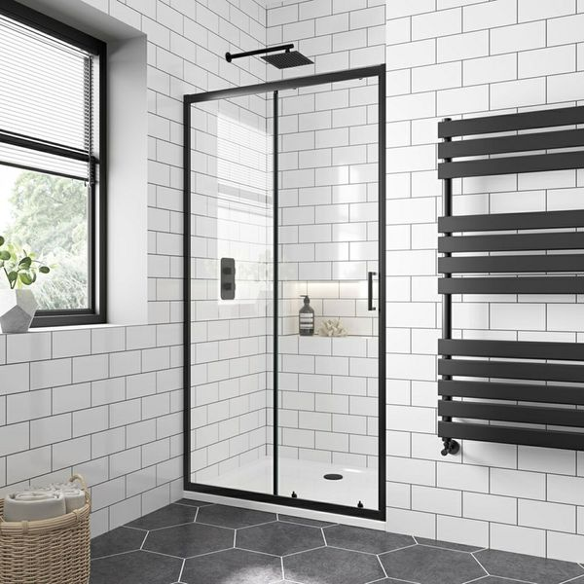**Flat Chalk Farm White Matt Tiles:**

## **Product Description**

Create a blank canvas in your kitchen or bathroom with these Flat Chalk Farm White Matt 200x100 Tiles. These flat-faced metro tiles are perfect for bringing a fresh, stylish and modern look into your home. White in colour, they act as a bright, blank background - great for accessorising with utensils, hanging signs, etc.

**What's so special about these tiles?**

> Subtle matt finish

> Highly versatile shape - perfect for different layouts

> Timeless white colour - perfect for classic kitchens and bathrooms

> Use with coloured grouts for unique looks

## **Product Info**

* Product ID: 13637
* Tiles Per SQM: 50
* Sale by: Per SQM
* Size: 100x200x7mm
* Weight: 0.28 KG
* Material Type: Ceramic
* Finish : Matt
* Colour: White
* Suitability: Walls
* Grade: No
* Rectified Edge: No
* Underfloor Heating : No
* Thickness (mm): 7